European Semester 2016/2017 shadow fiche on disability
FYR Macedonia | 
Report prepared by: Zvonko Shavreski; Elena Kochoska
With comparative data provided by the ANED core team

The Academic Network of European Disability experts (ANED) was established by the European Commission in 2008 to provide scientific support and advice for its disability policy Unit. In particular, the activities of the Network support the development of the European Disability Strategy 2010-2020 and practical implementation of the United Nations Convention on the Rights of Persons with Disabilities in the EU.

This country report has been prepared to shadow the European Semester input for EU28 countries from a disability perspective.

Note:
The statistics provided in October 2016 are based on the EU-SILC 2014. This is the most recent microdata available to researchers for analysis from Eurostat. This report may be updated as new data becomes available.



Contents

1 Summary of the overall situation and challenges 2
2 Assessment of the situation of disabled people with respect to the Europe 2020 headline targets 3
2.1 Strategic targets 3
2.1.1 A note on data from the State Statistical Office 4
2.2 Employment data 6
2.2.1 Unemployment 10
2.2.2 Economic activity 14
2.3 Education data 16
2.3.1 Early school leavers 17
2.3.2 Tertiary education 19
2.4 Poverty and social exclusion data 21
3 Description of the situation and trends in relation to each target area 25
3.1 Employment 25
3.2 Education 27
3.3 Poverty and social inclusion 28
4 Assessment of policies in place to meet the relevant headline targets 30
4.1 Employment 30
4.2 Education 32
4.3 Poverty and social inclusion 35
4.4 Synergies between developments in the different areas 36
5 Assessment of the ESIF 2014-2020 structural funds or other relevant EU funds in relation to disability challenges 37
6 Recommendations 38

Summary of the overall situation and challenges

Historically, Macedonia’s approach to disability has emphasised segregation for disabled children and menial employment for disabled adults, and has carried few if any policy tools to integrate disabled people into mainstream society. Left with few options and often confronting social stigma, many families institutionalised disabled relatives. Macedonia ratified the UN Convention on the Rights of Persons with Disability in 2011. Coupled with the strategic goal of full EU membership, Macedonia has an obligation to create favourable conditions for the enjoyment of human rights and freedoms by persons with disabilities, as well as to start to correct past wrongs and to meaningfully integrate disabled citizens into the country’s social and economic life. However, CRPD implementation remains unsatisfactory.

Employment, education and the social inclusion of persons with disabilities are among the most important topics in Macedonian disability policy. Indeed, they are included in all programmes that contain concrete goals and measures to improve the situation of persons with disabilities in all areas of life.

Concerning the status of persons with disabilities in relation to economic activity, the majority of them have remained economically inactive (in contrast with the total population). Reasons range from an inadequate legislative framework, a lack of accurate information, fear and non-trust of employers, lack of motivation on the part of persons with disabilities, the high unemployment rate of the general population and inadequate professional and vocational rehabilitation services on the ground. On the other hand, there have been several positive developments in the employment of this target group: the Government initiative to employ 300 persons with disability and the Government programme Macedonia Employs. Such programmes are temporary, however, and the infrastructure of a proper systematic legal employment framework in line with the CRPD is still missing. Further improvements in employment and the employability of persons with disabilities require changes to the transition from school to employment, which should become more efficient. At the same time, the content of education should be adapted to better correspond with labour market needs and should be open to include children with disability in the regular education system with properly developed support services.

Assessment of the situation of disabled people with respect to the Europe 2020 headline targets

The area of adequate standards of living and social protection requires significant improvement, too. In particular, the social protection system contains services and benefits without a properly developed system of indicators or a system of prevention. The projected benefits and measures are insufficient to cover the basic needs of people who are under social risk. The poverty rate of persons with disabilities in Macedonia has remained very similar to the poverty rate of the non-disabled population. Furthermore, there is no segregated data about the poverty rate of people with disability and the non-disabled population. Persons with disabilities have very often lived in households of low work intensity, with material deprivation. That is a reason why employment and social inclusion measures have to be focused on whole families with a member with disabilities. There must also be a proper functional categorisation of people with disability, and a policy for different support services needs to be defined and developed. Assessment of the situation of disabled people with respect to the Europe 2020 headline targets.

Strategic targets

Table 1: Europe 2020 and agreed national targets for the general population
 | Europe 2020 targets | National targets
Employment | 75% of the 20-64 year-olds to be employed | Not applicable
Education | Reducing the rates of early school leaving below 10% | Not applicable
Education | At least 40% of 30-34–year-olds completing third level education | Not applicable
Fighting poverty and social exclusion | At least 20 million fewer people in or at risk of poverty and social exclusion | Not applicable

Relevant disability targets from national strategies or sources:

There are no relevant disability targets in the national disability strategies for employment, education and fighting poverty or social exclusion.

A note on the use of EU data

Unless specified, the summary statistics presented in this report are drawn from 2014 EU-SILC micro data. The EU-SILC sample includes people living in private households and does not include people living in institutions. The proxy used to identify people with disabilities (impairments) is whether ‘for at least the past 6 months’ the respondent reports that they have been ‘limited because of a health problem in activities people usually do’. Responses to this question vary between countries and national data sources are added for comparison, where available.
Table 2: Self-reported ‘activity limitations’ as a proxy for impairment/disability (EU-SILC 2014)
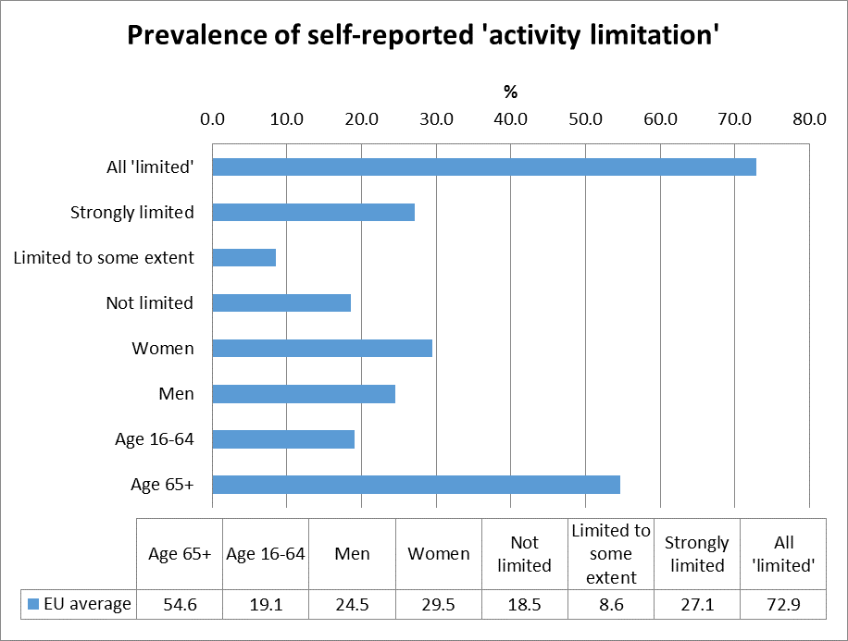
Source: EUSILC UDB 2014 – version 2 of August 2016

Only the EU28 average is shown where we do not hold data for the national case.

In subsequent tables, these data are used as a proxy to estimate ‘disability’ equality in the main target areas for EU2020 – employment, education and poverty risk. The tables are presented by disaggregating the estimated proportion of people who report and do not report limitations for each indicator (e.g. among those who are employed, unemployed, at risk of poverty, etc.).

A note on data from the State Statistical Office

The State Statistical Office survey on income and living conditions in Macedonia in 2013 included some data about the general population, in particular on whether people stated that ‘for at least the past 6 months’ they had been ‘limited because of a health problem in activities people usually do.’ The statistical data sample includes people living in private households and does not include data about people living in institutions.

Table 3: Self-perceived general state of health, 2011 - 2014
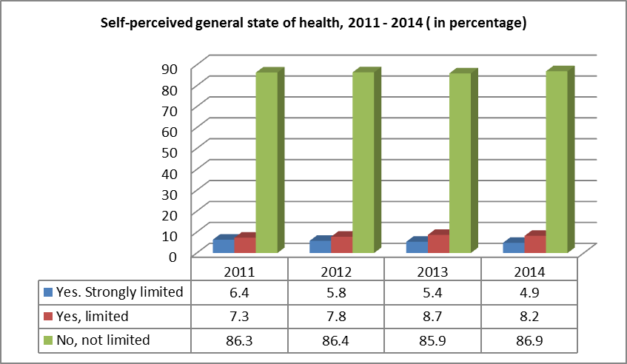
Source State Statistical Office of the Republic of Macedonia, May 2016

Table 4: Self-perceived general state of health, by age 2011 - 2014
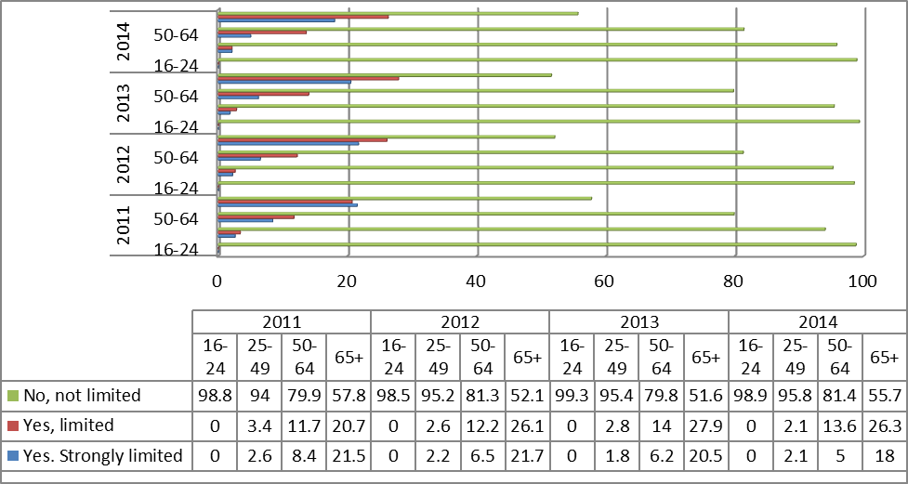
Source State Statistical Office of the Republic of Macedonia, May 2016

Table 5: Self-perceived general state of health, by gender 2011 - 2014
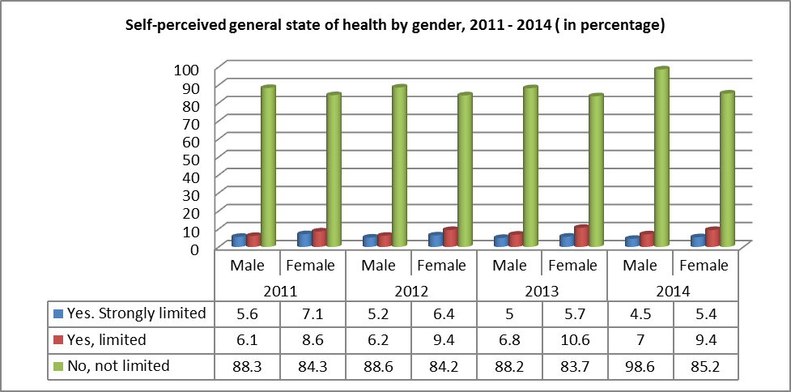
Source State Statistical Office of the Republic of Macedonia, May 2016

Employment data

As data for Macedonia was not available from the analysis of EU-SILC microdata in 2014, the following tables show the average situation across the EU Member States, for context. These are supplemented, where possible, with data provided by the national expert.

Table 6: Most recent employment data, aged 20-64
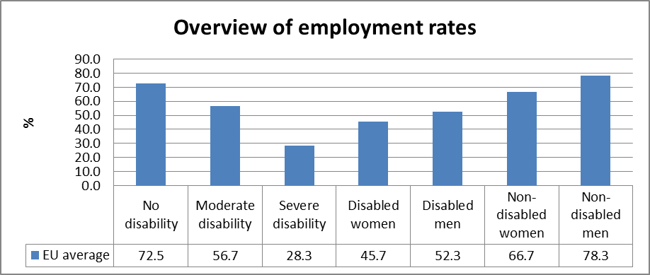
Source: EUSILC UDB 2014 – version 2 of August 2016
Table 7: Employment rate data, by age group
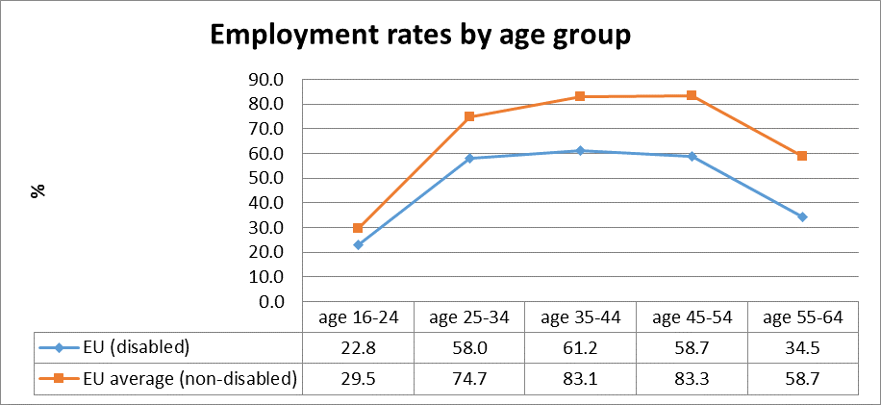
Source: EUSILC UDB 2014 – version 2 of August 2016

Table 8: Trends in employment by gender and disability (aged 20-64)
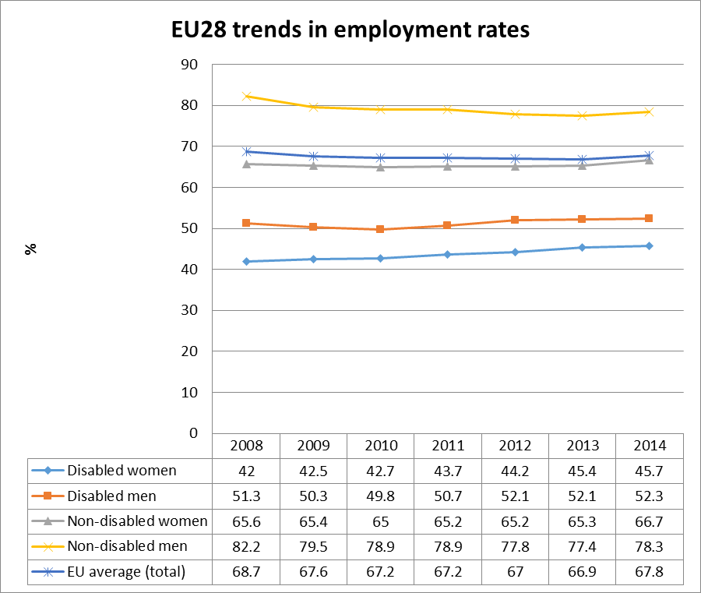
Source: EUSILC UDB 2014 – version 2 of August 2016 (and preceding UDBs)

The table above shows the EU2020 headline indicator for the EU as a whole.

Alternative data on disability and employment provided by the national expert:
No alternative data concerning the employment situation were identified.
Disability is calculated as a separate issue in the Labour survey. The rates for employment/unemployment are provided by National Agency for employment, Ministry for Labour and Social Policy etc. International institutions and domestic NGOs have also performed partial surveys (with inconsistent data).

There is some statistic about employment of people with disabilities in the sheltered companies. Therefore, the number of employed persons with disabilities in the sheltered companies, according the data from the Source State Statistical Office of the Republic of Macedonia for the 2015 is 2.158 persons, from which 741 are women with disabilities.

Table 9: Employed persons with disability in the shelter companies
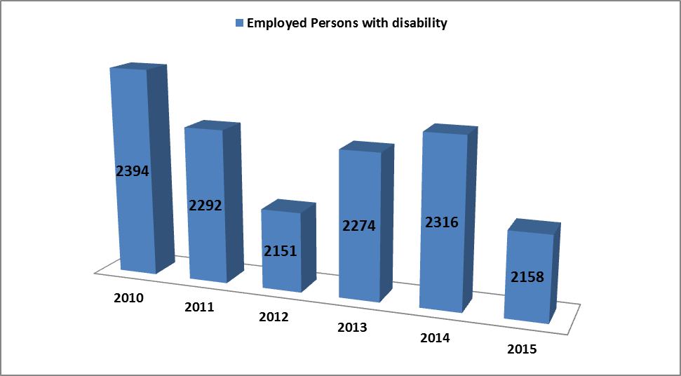
Source: State Statistical Office of the Republic of Macedonia

Table 10: Employed persons with disability in the shelter companies
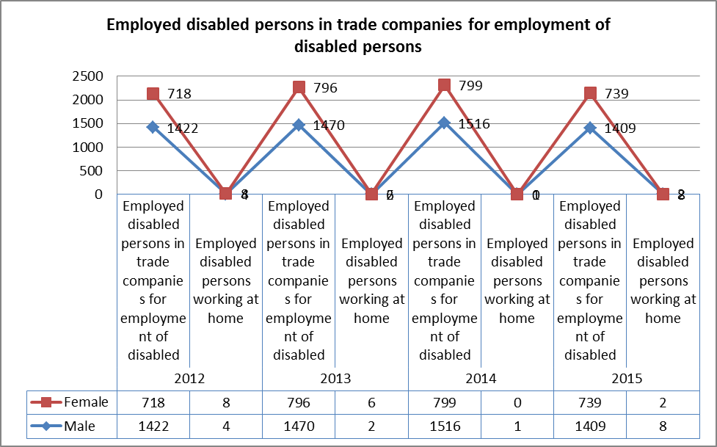
Source: State Statistical Office of the Republic of Macedonia

According the type of occupation 636 persons with a disability has an elementary occupation, 505 are employed as a plant and machine operators and assemblers, 480 are craft and related trades workers, 266 are service and sales workers, 201 are technicians and associate professionals; 55 are clerical support workers, 8 are skilled agricultural and fishery workers, 3 are professionals and scientists and only 2 are managers.

Considering the type of disability, most of the employees are those with intellectual disabilities (882) then are those with physical disability (423). It very high the number of other (314) who are not identified persons with or without disability.

Table 11: Employed disabled persons in trade companies for employment of disabled persons according to the legal basis and type of disability
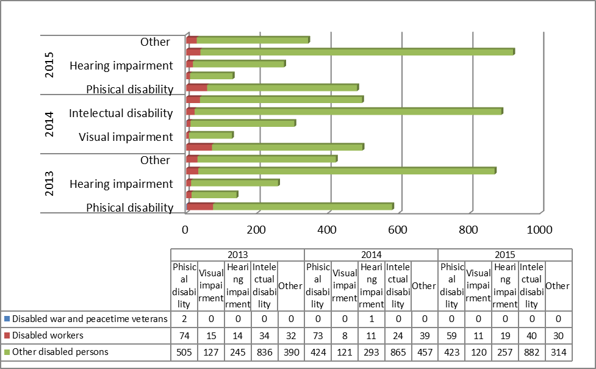
Source: State Statistical Office of the Republic of Macedonia

Unemployment

National administrative rules and definitions of ‘unemployment’ vary, and these may affect the way in which disabled people are categorised in different countries. The following tables compare national data with the EU2020 headline indicator for the EU.

Table 12: Most recent unemployment data, aged 20-64
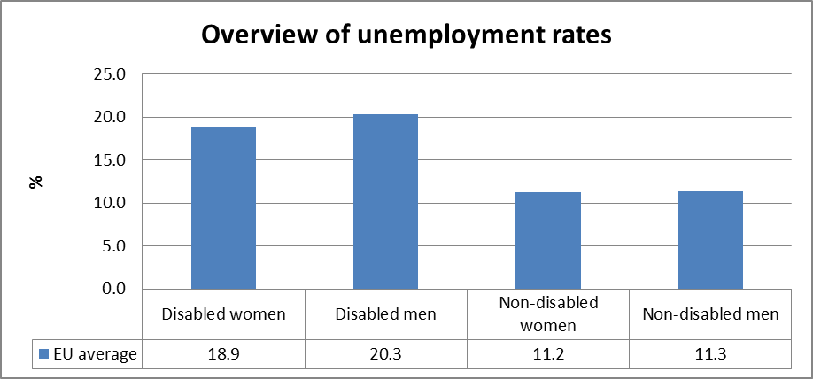
Source: EUSILC UDB 2014 – version 2 of August 2016

Table 13: Unemployment rate data, by age group
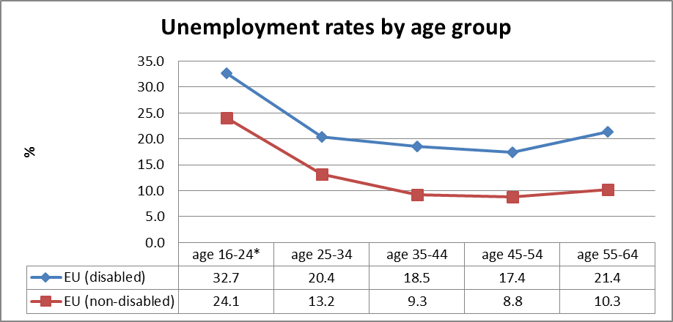
Source: EUSILC UDB 2014 – version 2 of August 2016

Table 14: Trends in unemployment by gender and disability (aged 20-64)
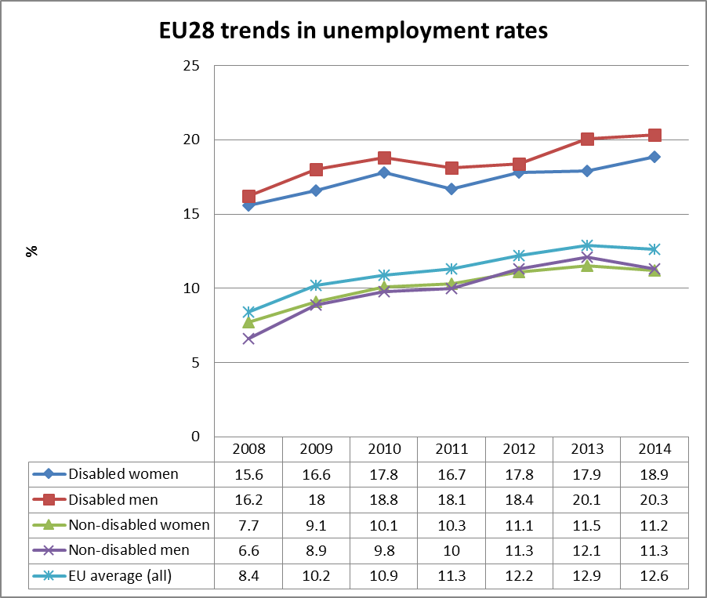
Source: EUSILC UDB 2014 – version 2 of August 2016 (and preceding UDBs)

The table above shows the EU2020 headline indicator for the EU as a whole.

Alternative data on disability and unemployment from national sources:

There is no existing appropriate statistical data or precise estimates on the number of persons with disability in the country, which does not allow for estimations of whether people with disabilities who are socially disadvantaged are covered mostly by the system of social protection.

Table 15: Unemployed persons with disability registered in Employment Agency
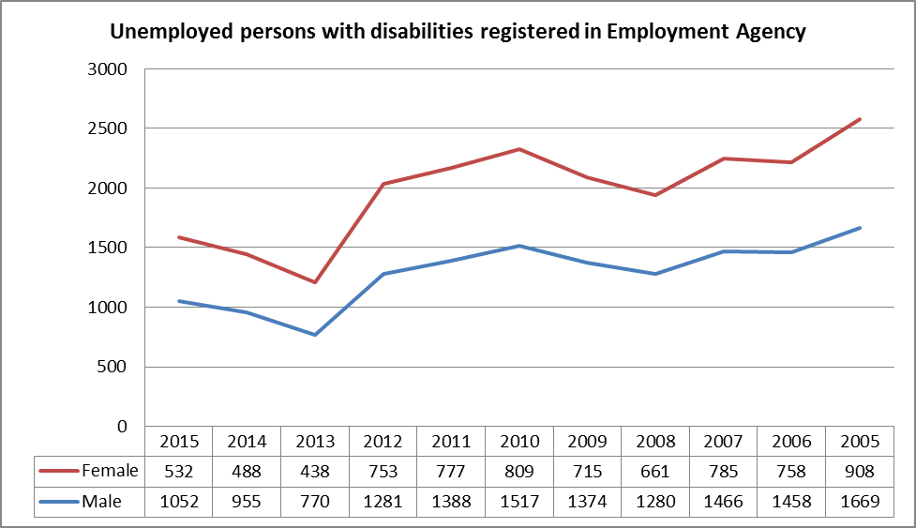Source: Employment agency of the Republic of Macedonia

According to the most recent data from the Employment Service Agency, at the end of 2015 there were registered 1.584 persons with disabilities as unemployed, of whom 532 were women and 1052 were men. On age structure, male persons aged 45 -49 and above were most likely to be unemployed, while from gender perspective the female aged 35 – 39 are most unemployed – see table 5. As regards their level of education, 853 unemployed persons are without any qualification, and 49 persons with finished faculty are registered. Concerning the type of disability, the majority (572 persons) of those registered as unemployed persons with disability had a mental disability, followed by persons with physical disability (420) and by those who were disabled as a result of work injury (127).

Table 16: Unemployed persons with disability structured by age
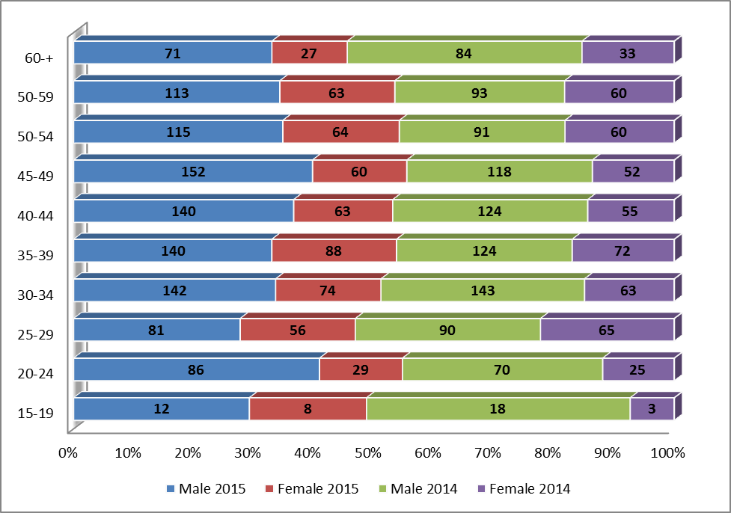
Source: Employment agency of the Republic of Macedonia

There are no comparison data among persons without and with disability who are unemployed. 13.130 persons stated that disability was one of the reasons why they were not looking for jobs. In comparison to 2014 3083 citizens has declared that disability is one of the reasons why they are not looking for job. If we add the cases of 27 698 persons who stated illness (since there is no distinction in the interpretation about disability and illness) as a reason why they were not looking for job, the situation is alarming.

Table 17: Reasons for not looking for job 2015
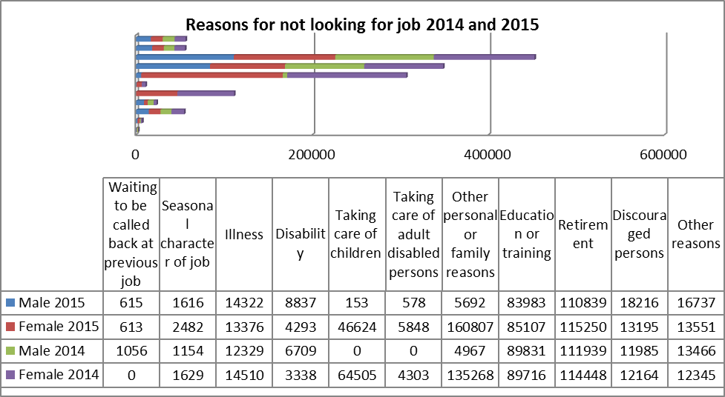
Source State Statistical Office of the Republic of Macedonia

Economic activity

Table 18: Most recent economic activty data, aged 20-64
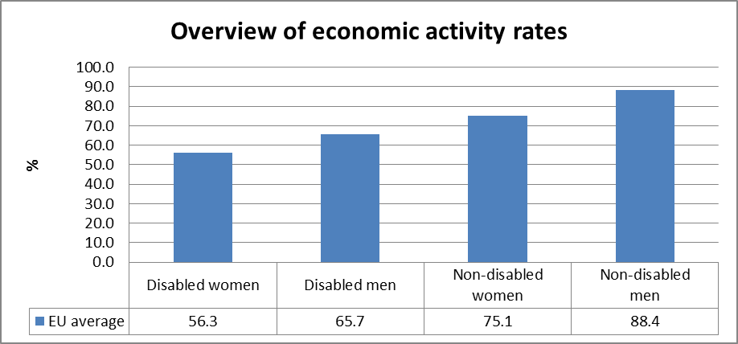
Source: EUSILC UDB 2014 – version 2 of August 2016
Table 19: Activity rate data, by age group
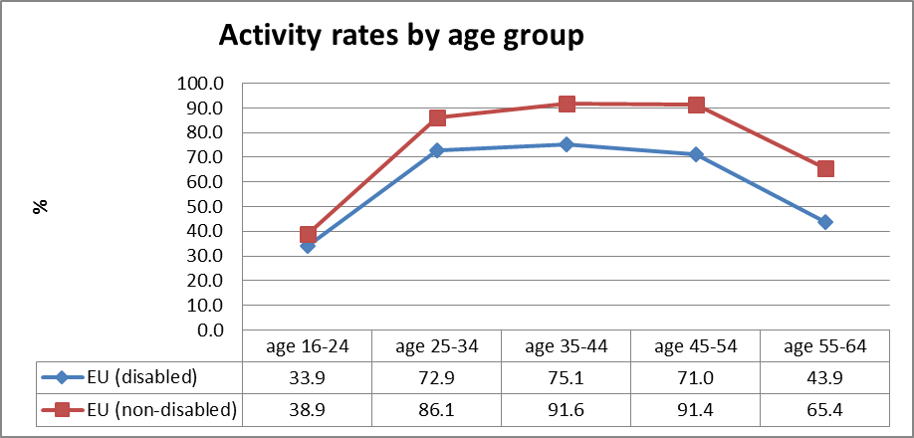
Source: EUSILC UDB 2014 – version 2 of August 2016

Table 20: Trends in activity rates by gender and disability (aged 20-64)
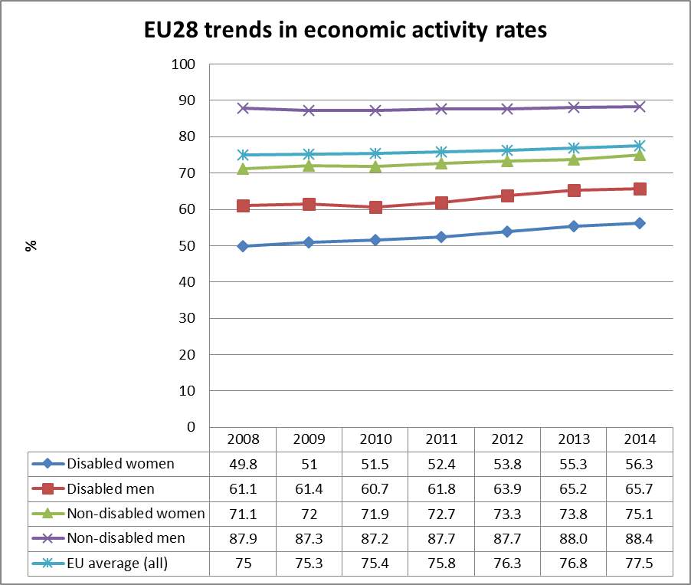
Source: EUSILC UDB 2014 – version 2 of August 2016 (and preceding UDBs)

The table above shows the EU2020 headline indicator for the EU as a whole.
Alternative data on disability and economic activity provided by the national expert:

According to the Labour Force Survey 2015, the population of persons over 15 years of age in the Republic of Macedonia for 2015 was 1,676,659, of which 57 % were active and participating in the labour market, while 43 % were outside the active population in 2014, i.e. they were inactive. There are no segregated data considering disability and also there are no statistical records about the activity, employment and unemployment rates for disability.

Table 21: Activity rates of the population for 2015
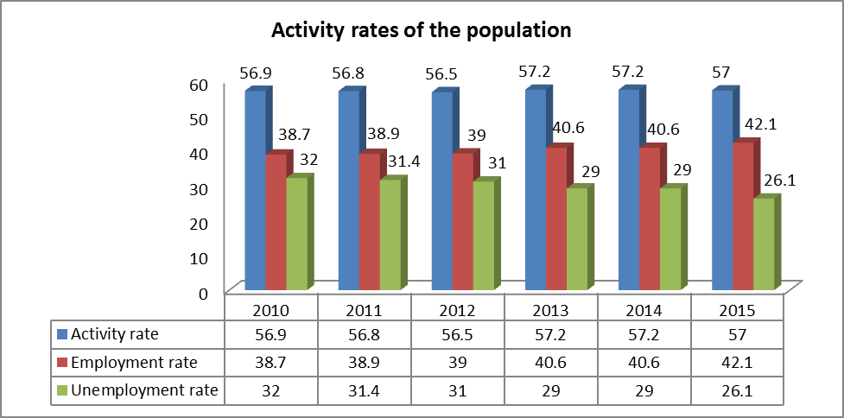Source State Statistical Office of the Republic of Macedonia

Education data

EU statistical comparisons are more limited concerning the education of young disabled women and men in the EU2020 target age groups. Data is available from EU-SILC (annually) as well as the Eurostat Labour Force Survey ad-hoc disability module (for 2011), but with low reliability for several countries on the key measures. Using a wider age range can improve reliability but estimations by gender remain indicative. EU trends are evident but administrative data may offer more reliable alternatives to identify national trends, where available.

Early school leavers

The EU-SILC sample for the target age group (aged 18-24) includes the following number of people reporting activity ‘limitation’ (as a proxy for impairment/disability).
Table 22: EU-SILC sample size in the target age group 18-24 versus 18-29
 | Age 18-24 |  | Age 18-29
 | No activity ‘limitation’ | Activity ‘limitation’ | No activity ‘limitation’ | Activity ‘limitation’
EU sample | 33,905 | 2,608 | 56,110 | 4,738
Source: EUSILC UDB 2014 – version 2 of August 2016

The following chart provides a summary of the EU average for context. This is supplemented by information from the national expert below.

Table 23: Early school leavers aged 18-24 (EU average based on above sample size)
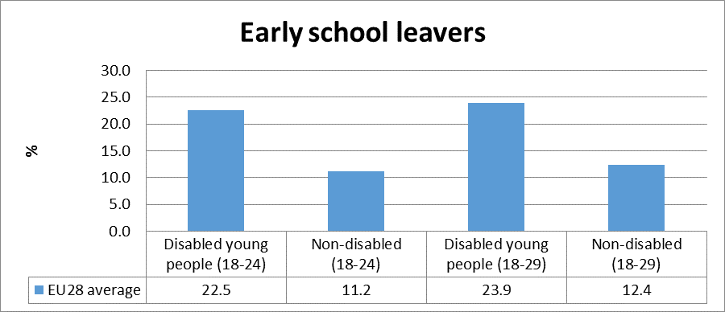
Source: EUSILC UDB 2014 – version 2 of August 2016

Alternative data on disability and early school leavers provided by the national expert:

The educational system of the Republic Macedonia consists of preschool, primary (6-14 years), secondary (15-17 / 18 years) and higher education. According the State Statistical Office the total number of children with disabilities is 834 (Table 13). This number only includes the number of children with disabilities in the primary and the one from the special secondary schools. It has to note that there is no evidence of children with disabilities in the regular preschool, primary, secondary or higher education. Disabled students get an education in 45 special primary and 4 special secondary schools. In many regular primary schools there are disabled students learning in separate classes.

Table 24: Special primary and lower secondary schools, students of disabilities
Special primary and lower secondary schools, students of disabilities
Years | Schools | Class section | Students
Years | Schools | Class section | total | female | students who finished school
 |  |  |  |  | total | Females
2011/2012 | 44 | 175 | 902 | 336 | 948 | 145
2012/2013 | 45 | 170 | 908 | 295 | 858 | 133
2013/2014 | 45 | 174 | 809 | 277 | 771 | 95
2014/2015 | 44 | 184 | 834 | 297 | 799 | 87
Source: State Statistical Office of the Republic of Macedonia

Table 25: Special primary and lower secondary schools, students by types of disabilities
Year 2014/2015 | Schools | Class sections | Students
Year 2014/2015 | Schools | Class sections | total | females | finished grade | finished school
Total | 44 | 184 | 834 | 297 | 799 | 87
Schools for students with intellectual disabilities | 38 | 146 | 697 | 241 | 671 | 68
Schools for educationally neglected students | 1 | 4 | 19 | 6 | 13 | 1
Schools for students with hearing impairments | 1 | 15 | 57 | 21 | 57 | 8
Schools for students with visual impairments | 2 | 11 | 41 | 21 | 39 | 8
Schools for students with hearing and speech impairments | 1 | 2 | 9 | 4 | 9 | 1
Schools for students with physical disabilities | 1 | 6 | 11 | 4 | 10 | 1
Source: State Statistical Office of the Republic of Macedonia

The data from the State statistical office outlines that in the secondary schools the numbers of student with disability for school year 2014/2015 is 260 students.

Table 26: Special upper secondary schools, students with disabilities
Years | Schools | Class section | Students
Years | Schools | Class section | total | female | students who finished school
 |  |  |  |  | total | Females
2011/2012 | 4 | 56 | 284 | 88 | 102 | 32
2012/2013 | 4 | 57 | 289 | 89 | 97 | 25
2013/2014 | 4 | 58 | 279 | 80 | 79 | 23
2014/2015 | 4 | 59 | 260 | 74 | 72 | 27
Source: State Statistical Office of the Republic of Macedonia

Table 27: Special primary and lower secondary schools, students of disabilities
Year 2014/2015 | Schools | Class sections | Students
Year 2014/2015 | Schools | Class sections | total | females | finished year
Total | 4 | 59 | 260 | 74 | 258
Schools for students with intellectual disabilities | 2 | 42 | 206 | 57 | 206
Schools for students with visual impairments | 1 | 7 | 17 | 6 | 17
Schools for students with hearing impairments | 1 | 10 | 37 | 11 | 35

Tertiary education

The EU-SILC sample for the target age group (aged 30-34) includes the following number of people reporting activity ‘limitation’ (a proxy for impairment/disability) although the number of missing observations is larger than the number of observations for activity limitation.

Table 28: EU-SILC sample size for the target age group 30-34 versus 30-39
 | Age 30-34 |  | Age 30-39
 | No activity ‘limitation’ | Activity ‘limitation’ | No activity ‘limitation’ | Activity ‘limitation’
EU sample | 23,740 | 2,744 | 50,243 | 6,572
Source: EUSILC UDB 2014 – version 2 of August 2016

Table 29: Completion of tertiary or equivalent education (indicative based on above sample)
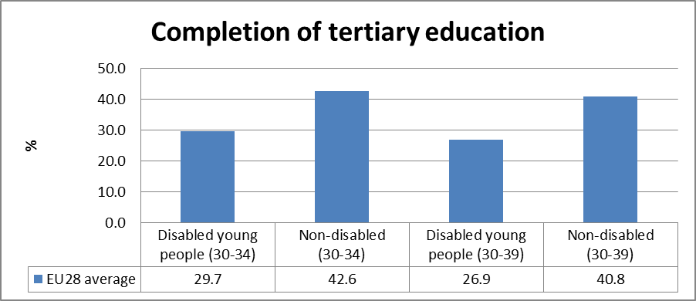
Source: EUSILC UDB 2014 – version 2 of August 2016

The survey sample is not sufficient to provide robust trend data disaggregated by gender in the narrow EU2020 target age group. In only 12 out of 28 Member States are there more than 50 observations in the sample for both women and for men in aged 30-34 who also declare impairment/limitation. In 5 there are fewer than 20 observations for women or for men, which cannot be reported.

The following table is indicative at the EU level but gender trends at the national level should be treated with caution. In all Member States except Austria the achievement of tertiary education was higher for women than for men in both groups.

Table 30: Trends in tertiary education by disability (aged 30-34)
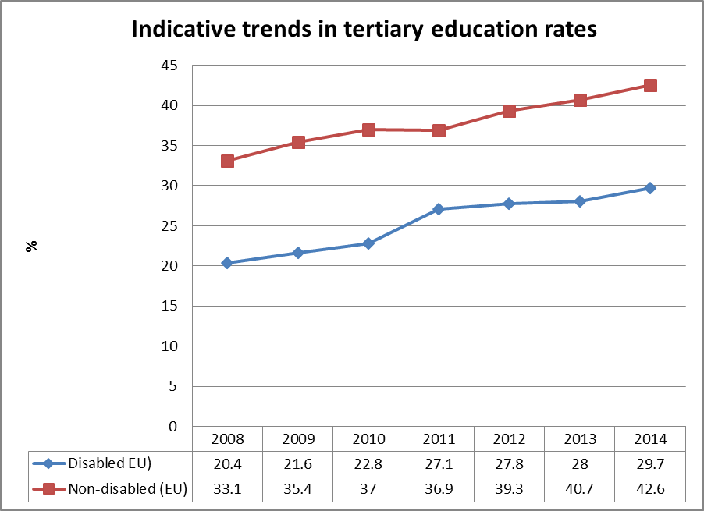
Source: EUSILC UDB 2014 – version 2 of August 2016 (and preceding UDBs)

Alternative data on disability and tertiary education provided by the national expert:

There are no official numbers of persons with disability in the tertiary education system.

Poverty and social exclusion data

EU SILC data provides indicators of the key risks for people with disabilities. In addition to household risks of low work intensity, there are risks of low income (after social transfers), and material deprivation. These three measures are combined in the overall estimate of risk. The risks for older people do not include work intensity (Eurostat refers to the age group 0-59 for this measure). The survey does not distinguish ‘activity limitation’ (the proxy for impairment/disability) for children under the age of 16. Relevant data provided by the national expert is added where available.

Table 31: People living in household poverty and exclusion by disability and risk (aged 16-59)
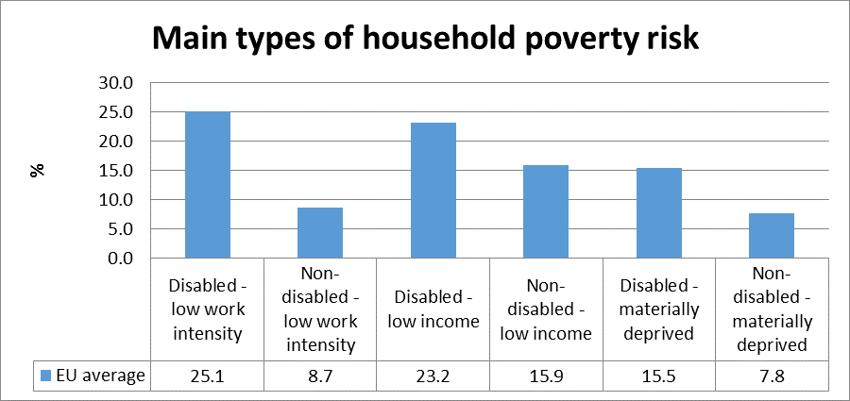
Source: EUSILC UDB 2014 – version 2 of August 2016

Table 32: People living in household poverty and exclusion by disability and gender (aged 16+)
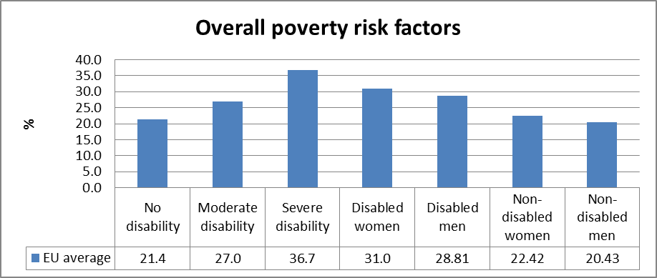
Source: EUSILC UDB 2014 – version 2 of August 2016

Table 33: Overall risk of household poverty or exclusion by disability and age (aged 16+)
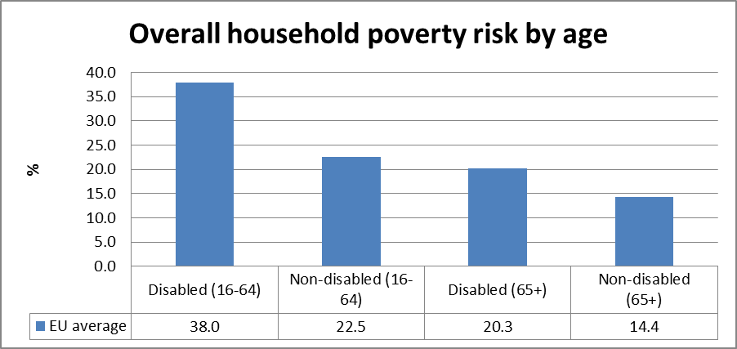
Source: EUSILC UDB 2014 – version 2 of August 2016

Table 34: Trends in household risk of poverty and exclusion by disability and age (EU-SILC 2014)
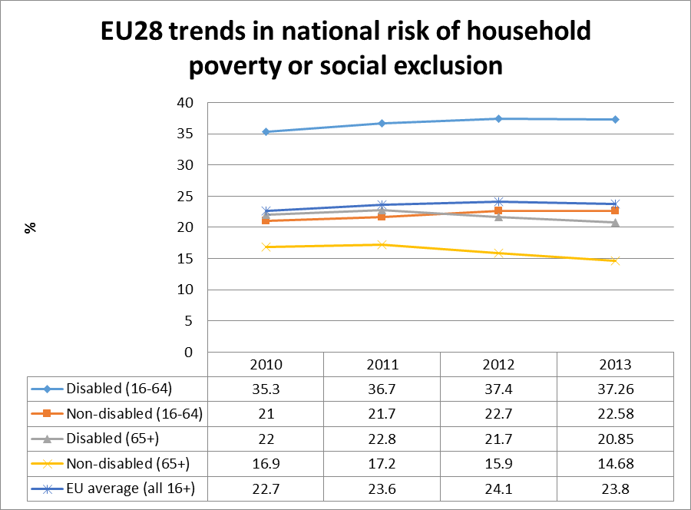
Source: EUSILC UDB 2014 – version 2 of August 2016 (and previous UDB)

The table above shows the EU2020 headline indicator for the EU as a whole.

Alternative data on disability and risk of poverty or social exclusion provided by the national expert:

There are no data about trends in household risk of poverty and exclusion disaggregated by disability. The general information about the poverty indicators from the State Statistics are as follows:

Table 35: Poverty and social exclusion indicators, 2012 - 2014
Laeken poverty indicators
 | 2011 | 2012 | 2013 | 2014
At-risk-of-poverty rate, % of population | 26.8 | 26.2 | 24.2 | 22.1
Number of persons below at-risk-of-poverty threshold, in thousand persons | 551.7 | 540.1 | 500.4 | 457.2
At-risk-of-poverty threshold of single-person household - annual equivalent income in MKD | 64 800 | 67 200 | 70 275 | 71 925
At-risk-of-poverty threshold of four-person household (2 adults and 2 children aged less than 14) - annual equivalent income in MKD | 136 080 | 141 120 | 147 578 | 151 043
At-risk-of-poverty rate before social transfers and before pensions, % of population | 43.9 | 42.6 | 41.0 | 41.7
Inequality of income distribution S80/S20 | 10.6 | 10.2 | 8.4 | 7.2
Inequality of income distribution Gini coefficient | 38.5 | 38.8 | 37.0 | 35.2

Description of the situation and trends in relation to each target area

Employment

The number of employed persons with mental and physical disability compared with the overall employed population in the Republic of Macedonia is quite small. The number of employed persons with disabilities is 2,158 (State Statistical Office, No. 2.4.15.04/813, 2015). Among those who have been employed and sent to rehabilitation, most have an intellectual disability (882 persons), then there are those with physical impairment (423 persons), those with hearing impairment (305 persons), and finally those with vision impairment (129 persons). There is also an ‘others’ category (319 persons). The data within the State official office is outlining the data only for the persons with disabilities employed in the sheltered companies or persons who are employed under the Law for the employment of people with disabilities. Those who are employed as all other citizens are not included in the statistical review.

On the other hand, the number of unemployed persons with disability for 2015 has been increase with 141 people with disability. At this point, unemployed persons with mental and physical disability are distributed among all age groups (aged 15 to 60 and above). Among the total number of unemployed persons with disability, 544 are persons with mental disability, 348 are persons with physical disability, and 147 are categorised as ‘labour invalids’.

A physically disabled person filed a submission to the Commission for Protection against Discrimination, claiming that article 1 of the Law on Employment of Persons with Disability was not in line with article 35 paragraph 3 of the Macedonian Constitution, since it did not encompass all categories of persons with disability, especially those who perform their occupation or profession independently (e.g. lawyers, doctors, notaries). According to the legal framework thus set up, persons with mental and physical disability cannot exercise the privileges provided by the state for the employment of persons with disabilities. Therefore, they are put in an unfavourable position relative to other persons with disability.

In this case, the Commission stated that it had no competence to act upon the request. At the same time, the Commission recommended that the claimant, in cooperation with the Commission for Protection against Discrimination, initiate an ‘authentic reading’ of article 1 of the Law on Employment of Persons with Disability. Thereby, it will be determined whether article 1 also covers the category of natural persons independently performing an occupation. The article itself is rather vague, because it mentions persons independently performing activities as a sole proprietor or employer, whereas the Law on Trade Companies does not recognise such a category. A sole proprietor is a natural person who performs a commercial activity as an occupation, and it is unclear how a person independently performing an activity can do so in the capacity of a sole proprietor (CPD, 2012 Annual Report, p. 22).

Surveys into this area point to fact that the persons with mental disability, followed by persons with physical disability, are discriminated against the most in employment, owing to the numerous prejudices against them. For example, it was noted that, although people for the most part do not mind cooperating with a disabled person in the workplace (72.3%), 29.8 % of respondents would nevertheless not accept a disabled person as their superior (Simoska, Gaber, Jovevska, Atanasov, Babunski, 2008, p. 35 and pp. 50-51). This is also confirmed by other surveys, which indicate that persons with disability are not accepted as being employed on an equal basis with others (NGO Ergos, Skopje, 2003), a phenomenon manifested through receiving less pay for the same work, lower chances for promotion, and harassment in the workplace. A total of 25.9 % of the respondents with a physical disability believe that they have been discriminated against in the workplace, with those in the age group 35-49 considering them as discriminated against most often. Another hot issue emerging from this survey is the multiple discrimination that are facing women and the elderly (aged over 50) with physical disability (Jovanova, Dimitrijoska, Tomovski, Ignjatovik, 2009).

Based on data from the analysis conducted by the Ombudsman, it can be concluded that there is a cyclical inclusion of mentally or physically disabled persons in the labour market. They numbered 636 in 2007, being mostly intellectually disabled persons. In 2008 the number of employed persons was 691, whereas persons with intellectual disability were once again most prominent and accounted for 40 % of the overall number.

The number of persons who established labour relations rose to 769 in 2009, whereas in 2010 the number of persons on established labour relations dropped to 504, only to rise to 604 in 2011. The Ombudsman thereby concluded that persons with disability are employed only in sheltered facilities, that they are underrepresented in the public sector, and that there is no proper communication between the employer and the person with disability for the purpose of accommodation in the workplace. At the same time, the Ombudsman concluded that there is a need to promote the process of categorising disabled persons and that the determination of the working position is solely a matter of agreement between the person and the employer, not the Commission of the MoLSP determining the person’s working capability (Situation and challenges ‒ Analysis of the employment of persons with disability, 2012, pp. 24-28).
In the latest monitoring of the personal experiences (Monitoring of the persons experiences of people with disabilities, 2015, pp.91), due to the discrimination and inequality, most of the responders had a high rate of negative experiences. Namely, 31.65% stated that they had experienced discrimination on a base on disability.
At the beginning of 2015 the Government has started to prepare a new legislation for employment of people with disabilities that will include a quota system and the same one needed to regulate the professional rehabilitation of these persons. Even the same draft was accepted by the Government, because of the business sector resistance the same one still is on the waiting list.

Education

The legal framework regarding kindergartens is inclusive and fairly clear. A problem occurs in some kindergartens where, in practice, they refuse to enrol children with disabilities – or, if the children are already enrolled, they have to leave because of minor problems. (Najchevska, Jandrijeska Jovanova, Chavkovska, Bajrami, ‘Invisible for society’ 2011, p.48). Persons with disabilities have lower levels of participation in all phases of the educational process, especially in secondary and higher education. People with mental disabilities often do not continue their education at a higher level. In fact, research has shown that 31.4 % of respondents believe that people with mental disabilities are the most discriminated against in education. Other types of disabilities and especially people with disabilities are far more acceptable to society (14.7 %) (‘How inclusive is Macedonian Society?’ research project, 2008). Also, there are limited educational opportunities for pupils with special needs. This is mainly related to the lack of the necessary physical capacity within schools, but is also due to the widely accepted notion that pupils with special needs should not be mixed with ‘normal’ pupils.

UNICEF assesses that only about 15 % of school-age pupils with special needs are enrolled into education (UNICEF, 2013). Deluca (2007) argues that either society is unable to correctly detect the mental disability of pupils or there is an open exclusion of such children from society. As was noted during an interview, ‘the best available option for parents who have a child with mental disability is to leave the country and move to more developed Western countries. However, this option is available only for rich households.’ (interview with university professor and practitioner from institution that works on social issues, 23.11.2012).

The studies have also shown that the inaccessibility of educational institutions and schools is another significant obstacle because only a small number of schools are accessible. Of a total of 334 primary schools, the report ‘Assistive technologies implementation into mainstream primary schools in Macedonia, current conditions and needs’ analyses 238 schools (71.3 %). Just 18.9 % of the schools had access ramps at their entrances, 10.9 % had customised rooms (classrooms and toilets), and none of them had an elevator. Another major problem in education is the accessibility of university faculties. Specifically, 62 faculties at the University of Ss. Cyril and Methodius are totally inaccessible (Disability Baseline report, Polio Plus, 2012).

Data from research conducted by Message, the national centre for people with intellectual disabilities, outlines that 38 % of parents stated that they had faced and still are facing discrimination in education, including inappropriate behaviour by teachers, by parents of children without disabilities, and by children without disabilities. 18 % of parents stated that their children had never been included in the educational process, i.e. had the opportunity to engage their children in education because of the child’s condition, which also represents a kind of discrimination. (RCLIP - Poraka Skopje 2010, pages 5-6).

Based on data from the analysis prepared by the Ombudsman in 2006 (Special report by the Ombudsman for the education of children with disabilities, 2006, pages 4-6), it can be concluded that children with disabilities who are included in regular elementary education usually do not finish at the same school, but study there for a few years. Then, some of them continue their education in special schools and some do not continue at all. An additional problem is the profile of teachers who need to work with these children. The Ombudsman’s research indicates that just 10 % of the schools have some trained teachers who are able to work with children with disability. Another big obstacle for inclusive education is awareness among the general public: 44 % think that children with disability need to go to special schools, and 33 % think that they should attend regular school but in separate classrooms; 12% think that children with disability need to go to regular school just for a few hours, and just 4% think that children with disability need to be in the regular education system (UNICEF, Knowledge, Attitude, Practice (KAP) Survey towards Inclusion of children with disabilities, November 2014). Additionally, the promotion and opening of a special school for blind pupils is a big step, and involves support from international institutions.

Poverty and social inclusion

The whole system is based on the medical model, and it was also recognised within the National Strategy on alleviation of poverty and social exclusion in the Republic of Macedonia 2010-2020. The strategy stated that non-institutional protection is present in the health and social protection system through a number of services, although they are insufficiently developed or coordinated by the bodies responsible, due to the lack of basic means for the work required (funds, vehicles, medical supplies etc.). The deinstitutionalisation of services for individuals with disabilities has resulted in a very small step forward in the strategy’s implementation within the social protection system, yet this is still not sufficient.

The distribution of household members according to the most frequent status shows that the share of employed was 23.7% in 2012, 22.8% in 2013, while 23.6% in 2014. Also, compared to 2013, the share of other inactive persons in 2014 increased to 22.5%. While 14.4% of households had problems with bad living conditions (leaking roofs, damp walls, broken windows and rot in window frames) in 2013, this percentage grew to 15.3% in 2014.

The conditions regarding the accessibility and quality of long-term care services in the country point to a number of problems and challenges which require attention. The main identified impediments to access to social and health services are: lack of information on existing services, lack of information for citizens regarding their rights, insufficient materials printed in community languages, and distance from existing social and health centres and institutions, which particularly affects the rural population, etc. The social model which provides for complete integration of these people in society is slow, due to insufficient administrative capacity and a shortage of professional staff. Non-institutional protection is present in the health and social protection system through a number of services, although they are insufficiently developed or coordinated by the bodies responsible, due to the lack of basic means for the work required (funds, vehicles, medical supplies etc.). The deinstitutionalisation of services for individuals with disabilities has resulted in a very small step forward in the strategy’s implementation within the social protection system, yet this is still not sufficient.

In this respect, the National Strategy for the alleviation of poverty and social exclusion presents a comprehensive outline of different domains (13 areas) with specific targets, measures and preconditions for each of these domains. It may be said that this wide-ranging approach fails to provide a more concrete identification of those at risk of poverty and socially excluded groups, as well as more concrete indicators on the basis of which it can be further implemented.

Assessment of policies in place to meet the relevant headline targets

Employment

Regarding national legislation, there are several provisions which, directly or indirectly, refer to protection from discrimination for persons with physical and mental disability in the field of labour relations. The Constitution of the Republic of Macedonia stipulates the right to work and related rights thereof in article 32. Article 35 paragraph 3 stipulates that the Republic provides protection for disabled persons, as well as conditions for their involvement in the life of society.

Article 6 of the Law on Labour Relations unequivocally prohibits discrimination per se, including disability-based discrimination by natural or legal persons in both the public and private sector. Of special interest is the provision stipulating that ‘[i]n concluding a contract of employment, the candidate shall not be obliged to submit proof of their health condition, unless the employer sends the candidate to an examination at their own expense’ (article 25 paragraph 5). These provisions fully meet the standards for protection against discrimination against persons with mental or physical disability, but they are being derogated if one takes into account the provisions of the Law on Civil Servants (concerning employment in the public sector), whereby general health capability is stated as a prerequisite for employment (article 9 paragraph 6, and article 13 paragraph 2 point 3). The same type of provisions can also be found in the Law on Courts (article 45 paragraph 1 point 3), the Law on Advocacy (article 12), the Law on the Police (article 95), the Law on Military Service (article 31), the Law on Foreign Affairs, and others. Besides the non-discrimination provisions, the law also contains special protection for, inter alia, persons with mental and physical disability (articles 122, 161-162, 164 and 169, 177-178). In addition to the special protection of workers with disability, the Law on Labour Relations also offers protection for workers who are parents of children with disability where one of the parents of a child with developmental problems and special educational needs has a right to work half working hours, but with these shortened working hours being considered as full working hours (article 169), until the child reaches the age of 26.

As regards persons with disabilities in the field of employment and the specific conditions for their employment and work, the important piece of legislation is the Law on Employment of Persons with Disability. Article 1 of the law stipulates that ‘[t]his law shall regulate the specific conditions for the employment and work of persons with disabilities in performing their occupation independently, under an employer or an acting employer, as well as the conditions establishing a trade company for employment of persons with disabilities, and the benefits thereof’. Practice shows that it fails to cover all categories of persons with disability, especially those performing their occupation or profession independently, that is, those who work in the capacities of lawyer, doctor or notary, for example, who are thus unable to realise the benefits ensuing from the law. From the analysis of the provision it follows that the article in itself is rather vague, owing to the fact that it mentions categories of persons which the Law on Trade Companies does not recognise, since a sole proprietor is a natural person who performs a commercial activity, whereas it is unclear how a person independently performing an activity can do so in the capacity of a sole proprietor. The law foresees a great number of stimulation measures aimed at improving the employment conditions of persons with mental and physical disability, such as: the awarding of non-refundable funds for the full-time employment of persons with disabilities, accommodations for the position designated for the disabled person should this be required, the procurement of equipment, tax exemption, the securing of contribution funds, and financial assistance for working. These stimulation measures are valorised into a number of monthly payments as non-refundable funds paid to the Special Fund set up under this law, as regulated by the Rulebook on the criteria and means of awarding non-refundable funds from the Special Fund for improvement of conditions for the employment and work of persons with disabilities. From the aspect of non-discrimination, the provision in article 4a paragraph 5 is disputable, whereas it is foreseen that ‘[a] person with disability can be an employer or a person in the function of a responsible person under an employer, if this person acquires a positive opinion from the Commission of the Ministry of Labour and Social Policy ...’ This provision is a classic example of discrimination beginning as a harassment and based on law.

Considering the national strategies, the revised version of the 2010-2018 National Strategy on Equal Rights of Persons with Disabilities was adopted in 2010. This strategy covers 17 separate units of action, among which is the area of professional and occupational orientation and employment of persons with disabilities. The following measures are envisaged for achieving this objective: strengthening the capacity of all institutions concerned; developing mechanisms and resources for professional rehabilitation and the development of vocational and professional training; motivating persons with disabilities; developing mechanisms for assessing the working capability of this group of workers; and promoting employment information systems (National Strategy, 2010, pp. 23-24).

When it comes to policy, the 2012-2015 National Strategy on Equality and Non-Discrimination and the 2012-2013 Operational Plan for Non-Discrimination on the Ground of Mental and Physical Disability are key documents when considering the issue of protection against discrimination on the ground of mental and physical discrimination, inter alia in the area of employment. The 2010-2020 National Strategy on the Reduction of Poverty and Social Exclusion considers four priority areas: employment; the informal economy and the enhancement of entrepreneurship; the labour market; and poverty and social inequality. It should be highlighted that, although persons with disability have not been explicitly identified as the strategy's particular target group, in area 1, which refers to employment, special focus is still given to creating equal opportunities in the employment of persons with special needs (result no. 4).

The 2015 National Employment Strategy is the basic document and framework defining employment policies. Unfortunately, however, it does not precisely cover increase of the employment rate for persons with disabilities among its priority objectives. Bearing in mind that these persons as a group are marked by a high unemployment rate and a low labour-market activity rate, their lack of coverage in the strategy gives cause for concern. These persons are only to be included within the wide definition of the term ‘other vulnerable groups’ covered in Guideline 7 of the strategy: Increased participation in the labour market and reduced structural unemployment. In 2013 the Government announced a measure for the employment of 300 persons with disabilities in the public administration – at present, 220 persons are employed there. According to the vacancy, this applies to those registered with the Employment Agency in the long term, with educational knowledge or skills not required.

Education

Article 44 of the Constitution of the Republic of Macedonia stipulates the right to education and the related rights thereof. In addition, it requires that everyone, under equal conditions, has education available to them, while primary education is compulsory and free. Article 35 paragraph 3 stipulates that the Republic provides protection for disabled persons, as well as conditions for their involvement in the life of society.

In the area of education of people with disabilities, several provisions are important: the Law on Primary Education, the Law on Secondary Education, the Law on Higher Education and the Law on Vocational Education and Training. Other provisions also apply, for example the Law on Lifelong Education, but this does not include any provisions considering persons with disabilities. The Law on Primary Education is free and compulsory for everyone. According to article 6 of the Law on Primary Education, students with disabilities (in the law they are referred to as students with special educational needs) shall be provided with appropriate conditions for the acquisition of primary education in mainstream and special schools, and they have the right to individual aid for the acquisition of primary education.

If this article is read in conjunction with article 10 paragraph 3, which states that ‘the main education for students with special educational needs is organised and conducted in special schools and special classes in regular schools’, we come to the conclusion that the inclusion of these children is only declarative and that the actual aim of the legislator is not the education of children with disabilities together with other children without disabilities in the same classes, but their segregation. Where the learning of a child with disability depends largely on the choice of the parent, the parent has the right to enrol their child with disability in the mainstream education system, ‘except in cases when the educational needs of the child are such that he or she needs to attend a special elementary school’ (article 51, paragraph 1). Considering curriculums, the law provides for special curriculums to be organised, with educational activities being conducted for students with special needs, tailored to their specific educational needs (article 30). These adjusted curriculums should be of an equal quality to those that are used for the education of children without disabilities.

While primary education is at least inclusive, secondary education for persons with disabilities is far more segregated. According to article 39 paragraph 1 of the Law on Secondary Education, ‘in secondary education for students with special educational needs students are educated according to the programmes relevant to occupations or educational profiles or vocational skills.’ So, regardless of the potential of persons with disabilities in accordance with the legal framework, they are destined for menial and low-paying jobs.

The Law on Higher Education stipulates that all citizens have, under equal conditions, the right to education in higher education institutions (article 7), while the anti-discrimination provision applies only to the selection procedure for candidates. Article 108 paragraph 5 of the law provides that the procedure for selecting candidates for enrolment in higher education institutions guarantees equality for all applicants, regardless of, inter alia, their disability (the law refers to ‘invalids’). The other two provisions of the law that mention people with disabilities concern the protective measures that faculties provide for students with disabilities to study. The first of these is about the free participation (free of payment) of persons with the first or second category of disability (article 87, paragraph 3), and the second provision refers to the right to special benefits as stipulated by the higher education institution statute for, inter alia, blind and deaf students and invalids in the first and second group (article 150, paragraph 4). A general anti-discrimination clause does not exist in this legislation, as in other legislation in the sphere of education.

The Law on Vocational Education and Training regulates the rights and obligations of vocational education and training institutions, as well as those of employers involved in practical training and the organisation and implementation of vocational education and training of different types, levels and duration. This law contains no specific measures for the inclusion of persons with disabilities.

Preschool education is regulated by the Law on Child Protection, under which public kindergartens organise the care and education of children with disabilities according to the type and degree of disability (article 48). The care and education of children with disabilities are performed in regular groups, providing additional assistance and tailored programmes, with separate groups for children with moderate disabilities according to the specific programmes.

Teachers’ work with students with special educational needs is assessed on the basis of the Law on Educational Inspection. According to the Rulebook on the manner and procedure for Education Inspection, guidelines have been developed, which aim to regulate the rules for evaluating the fulfilment of teachers’ and associates’ duties in primary and secondary education. The guidelines state: ‘The teacher is awarded 8 points if he/she is teaching in classes that include students with special educational needs (with inclusion), if he / she is working partially on that basis, then his/her work gains 4 points’.

The Law for protection from and the prevention of discrimination prohibits all forms of discrimination committed by natural and legal persons in both the public and the private sector, inter alia in the area of education (article 4, paragraph 1, point 2). Articles 13-15 provide for exceptions to discrimination, whereas those relevant to persons with disability in the area of education provide for the following: no action will be deemed discrimination if it is a measure foreseen by law and is undertaken in special cases when affirmative measures are taken (article 13); there shall be different treatment for persons with disabilities in training and in acquiring education to the effect of satisfying their special educational needs, with the aim of equalisation of opportunities (article 15 paragraph 1 point 3); as stipulated by law, special protection shall be provided, inter alia, to persons with disability (article 15 paragraph 1 point 7).

Considering the national strategies, a revised version of the 2010-2018 National Strategy on Equal Rights of Persons with Disabilities was adopted in 2010, as well as the 2012-2015 National Strategy on Equality and Non-Discrimination and the 2012-2013 Operational Plan for Non-Discrimination on the Ground of Mental and Physical Disability. The 2010-2020 National Strategy on the Reduction of Poverty and Social Exclusion, the National Programme for educational development in the Rep. of Macedonia (2005 – 2015) and the Local Strategy for development in secondary education in the City of Skopje (2012- 2016) contain some provisions on the education of students and pupils with disability, but only in a declarative manner, without any concrete measures or an effective plan for the inclusion of persons with disabilities in the regular education system in Macedonia.

Poverty and social inclusion

The system of social protection under the corresponding legislative acts provides comprehensive coverage for persons facing problems of material deprivation, poverty and social exclusion in the country. The main laws according to which people facing these problems can acquire certain social rights include the Law on Social Protection, the Law on Employment and Unemployment Insurance and its subsequent changes, the Law on Minimum Incomes and the Law on Pension and Disability Insurance and its subsequent changes, as well as separate by-laws and other ‘soft’ legislation such as strategies, national action plans, annual programmes and other governmental decisions and measures. There are also other important legislative acts (for health, social housing etc.).

The main social rights and services which can be obtained through the Law on Social Protection are provided through social prevention, institutional support, day care services and financial assistance. Financial assistance in particular includes 10 different rights, among which three are general benefits programmes – social financial assistance (for those capable of work); permanent social assistance (for those not capable of work); and one-time financial assistance and compensation in kind; seven are categorical benefits such as: financial assistance to persons who until the age of 18 had the status of child without parents or parental care; financial assistance to a mother with a fourth child; financial assistance for support and care from a third person; wage supplements for shortened working hours due to the need to provide care for a child with physical or mental disabilities; financial assistance for social housing; the right to health protection; and a supplement for blindness and mobility (art. 44).

Prevention, protection, outreach and care services still lack sufficient financial and human resources notably with reference to children with disabilities, street children, children using drugs and children who are victims of domestic violence, sexual abuse or trafficking. Some limited progress can be reported in the treatment of the socially vulnerable and/or persons with disabilities. Social services are slowly being deinstitutionalised and civil society is slowly increasing its provision of social care services. However, the fiscal and administrative decentralisation of social services is still limited. The implementation of adopted policies is slow. The issues of poor material conditions, inhumane practices and degrading treatment in psychiatric institutions need to be addressed. The social integration of people with disabilities is very limited. The poverty rate remains very high. This situation has been confirmed in the latest Progress Report.

Synergies between developments in the different areas

Persons with disabilities are not perceived as an important, valued group, which results in the issue being lost in the political and financial agenda. The low awareness among the general population and among persons with disabilities leads to disability issues being transferred from one department to another, getting stuck in the Ministry of Labour and Social Policy. Another issue that leads to negative synergy is the categorisation and segregation of persons with disabilities according to degree and cause of disability. The slow and insufficient implementation of CRPD is not only a sign of unwillingness to change the living conditions of persons with disabilities; it is also a barrier against disability mainstreaming in sustainable disability policies.

Assessment of the ESIF 2014-2020 structural funds or other relevant EU funds in relation to disability challenges

The EU funds in Macedonia are allocated through IPA funds and the EIDHR programme. According to the EU, the allocated funds under IPA II for Macedonia in the period 2014-2020 come to EUR 664.2 million.

Within this measure of IPA, funds were allocated for two projects/ tenders concerning persons with disabilities. The first one commenced in January 2012 – ‘Fostering social inclusion and an inclusive labour market’. This project was extended for 20 months, with a total value of EUR 1.5 million. One of its components was the ‘integration of persons with disabilities in the labour market’. In the report “The use of EU funds in Macedonia’ (European Policy Institute, page 76), it is stated, ‘it is not clear whether the activities envisaged by the second component – integration of disabled persons – will finally contribute to the implementation of the national strategy on equal rights for people with disabilities (2010-2018), for which the two last progress reports note that has not progressed’. The other project in line with the previous is running at the moment and is targeting the vocational rehabilitation and personal assistance for people with disability.

The Civil Society Facility (CSF) launched in 2008. The CSF offers an opportunity to better meet the needs of the region by providing support to civil society development and dialogue. This will be coordinated and streamlined by focusing on different areas of intervention such as civic initiatives and capacity building at a national level, with ‘People 2 People’ visitor projects as well as activities carried out in multilateral partnerships between CSOs both in the Western Balkans and Turkey and in the EU, which may lead to a transfer of knowledge and the set-up of new networks, as well as trans-national innovative projects.

According to the TACSO report, most of the associations and foundations involved (85 %) have an annual budget of up to MKD 100 000 (around EUR 1 600) (Central Registry, 2011), which leads to the conclusion that the vast majority of CSOs have and operate with very limited funds. According to the same report, the larger, fully professional CSOs tend to enjoy relatively high levels of financial stability owing to their ability to access funds from multiple international donors. Small organisational size and poor technical skills effectively exclude a majority of CSOs in Macedonia from competing for EC funds. Since disability organisations have more organisational and operational limits within all CSO sectors, the perception is that most of them are not even trying to apply.

Recommendations

Generally, disability policy is considered to be only one sub-chapter of social policy, not a distinct policy field itself. Measures for persons with disabilities are mostly provided by the Ministry of Labour and Social Policy, even for issues that are not in their field of work.

- Enacting legislation for the rights and dignity of people with disabilities
- Enacting the new law for the employment of persons with disability promoting an inclusive labour market
- Developing regulatory policy for support services for people with disabilities
- Developing a system for the vocational rehabilitation and profiling of persons, and for the centres to conduct this
- Enacting a new model of categorisation for people with disability
- Enacting and developing new mechanisms for inclusive education and increasing awareness among all stakeholders and the general public
- Reforming the Management Board of the Special Fund for the employment of persons with disabilities, where the representatives of DPOs will be responsible for and involved with the social dialogue for this topic
- Re-establishing existing cash benefits in line with the principles of CRPD as well as developing a new one
- Reprogramming the EU funds for Macedonia, highlighting the issue of disability
- Disability must be part of all statistical data segregated by all fields, including for GDP
- Increasing the participation of people with disabilities in all high-level political and institutional structures, including the EU
- Developing a comprehensive and sustainable plan for de-institutionalisation and the establishment of reliable support structures for persons with disabilities to live independently in the community.

http://ec.europa.eu/europe2020/pdf/targets_en.pdf.
EUSILC UDB 2014 – version 2 of August 2016.
The SILC survey questions are contained in the Minimum European Health Module (MEHM) http://epp.eurostat.ec.europa.eu/statistics_explained/index.php/Glossary:Minimum_European_Health_Module_(MEHM).
The methodology is further explained in the annual statistical reports of ANED, available at http://www.disability-europe.net/theme/statistical-indicators.
State Statistical Office of Rep. of Macedonia, Social welfare for children, juveniles and adults, 2015, Statistical Review: 2.4.16.12/859, page 31 Available on http://www.stat.gov.mk/Publikacii/2.4.16.12.pdf.
State Statistical Office of Rep. of Macedonia, Social welfare for children, juveniles and adults, 2015, Statistical Review: 2.4.16.12/859, page 32 Available on http://www.stat.gov.mk/Publikacii/2.4.16.12.pdf.
Ibid 11, page 33.
Ibid 11, page 32.
Data are gathered from the separated reviews by years, from the Employment Service Agency Available http://www.avrm.gov.mk/lica-so-posebni-potrebi.nspx.
Data from the State Statistical Office of the Republic of Macedonia, Labor Force Survey, 2015, page 98 Available on: http://www.stat.gov.mk/Publikacii/2.4.16.02.pdf; Data from the State Statistical Office of the Republic of Macedonia, Labor Force Survey, 2014, page 92 Available at: http://www.stat.gov.mk/Publikacii/2.4.15.04.pdf.
State Statistical Office of Rep. of Macedonia, Labour Force Survey, 2014, Statistical Review: Population and Social Statistics 2.4.15.04 813, Skopje, June 2015 http://www.stat.gov.mk/Publikacii/2.4.15.04.pdf.
State Statistical Office of Rep. of Macedonia, Labour Force Survey, 2015, Statistical Review: 2.4.16.02 /843, Skopje, page 122, Available on http://www.stat.gov.mk/Publikacii/2.4.16.02.pdf.
For the LFS AHM data see, Early school leavers http://appsso.eurostat.ec.europa.eu/nui/show.do?dataset=hlth_de010&lang=en and tertiary educational attainment http://appsso.eurostat.ec.europa.eu/nui/show.do?dataset=hlth_de020&lang=en.
State Statistical Office of Rep. of Macedonia, Primary, Lower Secondary and Upper Secondary Schools, page 40 Available on http://www.stat.gov.mk/PublikaciiPoOblast.aspx?id=41&rbrObl=5.
State Statistical Office of Republic of Macedonia, Primary, Lower Secondary and Upper Secondary Schools, at the end of the school year 2014/2015, Statistical Review: Population and Social Statistics, 2.4.16.06/851, page 40 Available on http://www.stat.gov.mk/Publikacii/2.4.16.06.pdf.
Ibid 15, page 62.
Ibid 16, page 62.
Source: State statistical Office of the Republic of Macedonia, Survey on Income and Living Conditions, 2014, Statistical Review: Incomes, Expenditures and Prices, May 2016. Page 37, available on: http://www.stat.gov.mk/Publikacii/2.4.16.04.pdf.
State Statistical Office of Rep. of Macedonia, Labour Force Survey, 2015, Statistical Review: 2.4.16.02 /843, Skopje, page 122, Available on http://www.stat.gov.mk/Publikacii/2.4.16.02.pdf.
Employment Service Agency, Review for unemployed persons with disability until 31.12.2015. Available at http://www.avrm.gov.mk/content/Statisticki%20podatoci/%D0%94%D0%B5%D0%BA%D0%B5%D0%BC%D0%B2%D1%80%D0%B8%202015/PIvidnainvalidnost122015.pdf.
2012 Regular annual report of the Commission for Protection against Discrimination, Commission for Protection against Discrimination, Skopje, 2013. Available at: http://www.kzd.mk.
Simoska E., Gaber N., Jovevska A., Atanasov P., Babunski K., Research Project: How Inclusive is the Macedonian Society, Foundation Open Society Institute ‒ Macedonia, 2008. Available at: http://www.soros.org.mk.
Employment of Persons with Disability during Transition, NGO Ergos, Skopje, 2003. Available at: http://www.nvoinfocentar.org.mk/event.asp?site=nvo&menu=%203&lang=mak&id=92.
Jovanov V., Dimitrijoska S., Tomovski S., Ignjatovik M., The position of the physically disabled persons on the labour market ‒ study of the conducted research, with the support of UNIFEM, Skopje, December 2009.
Situation and challenges ‒ Analysis of the employment of persons with disability, Ombudsman of the Republic of Macedonia, Skopje, 2012. Available at: http://www.ombudsman.mk/.
Publication: “Monitoring of the personal experiences of people with disabilities, 2015, pp.91, http://www.openthewindows.org/sites/default/files/3._monitoring_na_licni_iskustva_._web.pdf.
Research project How inclusive is the Macedonian Society” Soros – Macedonia, 2008. Available at http://www.soros.org.mk.
Mapping of VET educational policies and practices for social inclusion and social cohesion Country Study: Former Yugoslav Republic of Macedonia, 2012/2013. Available at http://www.etf.europa.eu/webatt.nsf/0/DAB114816ADBC32DC1257C2100330873/$file/FYR%20MACEDONIA%20-%20FINAL%20Report.pdf.
‘Assistive technologies implementation into mainstream primary schools in Macedonia, current conditions and needs’, available at http://www.openthewindows.org/.
Disability Baseline report, Polio Plus, 2012. Available at www.polioplus.org.mk.
RCLIP -Poraka Skopje 2010, pages 5-6.
Special report by the Ombudsman for education of children with disabilities, 2006, Available at: http://ombudsman.mk/upload/documents/Posebni%20potrebi%20na%20decata1%20-mak.pdf.
UNICEF, Knowledge, Attitude, Practice (KAP) Survey towards Inclusion of children with disabilities, November 2014.
Article from the media: http://meta.mk/otvoren-nov-objekt-vo-uchilishteto-za-detsa-so-oshteten-vid-dimitar-vlahov/.
National Strategy for National strategy on alleviation of poverty and social exclusion in the Republic of Macedonia 2010-2020, available at http://mtsp.gov.mk/WBStorage/Files/strategy.pdf.
Ibid 19.
Law on Labour Relations, available at http://www.mtsp.gov.mk/content/pdf/zakoni/ZRO%20Precisten%2074-15.pdf.
Analysis of discriminatory practices in the area of employment and labour relations, 2013 Polio Plus.
Rulebook on the criteria and means of awarding non-refundable funds from the Special Fund for improvement of conditions for employment and work of persons with disabilities. www.mtsp.gov.mk.
2010-2018 National Strategy on Equal Rights of Persons with Disabilities (revised version), Ministry of Labour and Social Policy, 2009. Available at: http://www.mtsp.gov.mk.
2012-2015 National Strategy on Equality and Non-Discrimination on the Grounds of Ethnicity, Age, Mental/Physical Disability and Sex. adopted by the Government of the Republic of Macedonia in May 2012. Available at: http://www.mtsp.gov.mk/?ItemID=BD66FCC3A7FBCB47AB9150CBFECD2C96.
Operational Plan for the implementation of the 2012-2015 National Strategy on Equality and Non-Discrimination on the Grounds of Ethnicity, Age, Mental/Physical Disability and Sex adopted by the Government of the Republic of Macedonia in January 2013. Available at: http://www.mtsp.gov.mk/?ItemID=BD66FCC3A7FBCB47A B9150CBFECD2C96.
2010-2020 National Strategy on the Reduction of Poverty and Social Exclusion in the Republic of Macedonia, Ministry of Labour and Social policy. Available at: http://www.mtsp.gov.mk/?ItemID=BD 66FCC3A7FBCB47AB9150 CBFECD2C96.
2015 National Employment Strategy of the Republic of Macedonia, Ministry of Labour and Social Policy, Skopje, August 2012. Available at: http://www.mtsp.gov.mk/WBStorage/Files/nsvrab.pdf.
Employment of persons with disabilities in the public administration. Available at http://www.independent.mk/articles/21066/Macedonia+Plan+to+Employ++Disabled+Persons+near+Completion.
The vacancy from the Government for employment of people with disabilities. Available at http://vlada.mk/node/7594?language=mk.
Law on Primary Education. Available at http://www.mon.gov.mk/images/documents/zakoni/zakon-za-osnovno-20155.pdf.
Analysis of discrimination in the education of persons with disabilities, Polio Plus 2014.
Law on secondary education, available at http://mon.gov.mk/images/documents/zakoni/zakon-za-sredno-2015.pdf.
Law on higher education, available at http://www.mon.gov.mk/images/documents/zakoni/zakon-za-visoko-2015.pdf.
Law on vocation education and training, available at http://www.mon.gov.mk/images/documents/zakoni/zakon-za-strucno-obrazovanie-i-obuka.pdf.
Law on Educational Inspection, available at http://www.mon.gov.mk/images/documents/zakoni/zakon-za-prosvetna-inspekcija-2015.pdf.
Inspection guidelines, available at http://www.takidaskalo.edu.mk/TakiDaskalo/documents/Upatstvo_za_vrednuvanje_na_nastavnicite.pdf.
Law for protection from and the prevention of discrimination, available at www.kzd.com.
2010-2018 National Strategy on Equal Rights of Persons with Disabilities (revised version), Ministry of Labour and Social Policy, 2009. Available at: http://www.mtsp.gov.mk.
2012-2015 National Strategy on Equality and Non-Discrimination on the Grounds of Ethnicity, Age, Mental/Physical Disability and Sex. adopted by the Government of the Republic of Macedonia in May 2012. Available at: http://www.mtsp.gov.mk/?ItemID=BD66FCC3A7FBCB47AB9150CBFECD2C96.
Operational Plan for the implementation of the 2012-2015 National Strategy on Equality and Non-Discrimination on the Grounds of Ethnicity, Age, Mental/Physical Disability and Sex adopted by the Government of the Republic of Macedonia in January 2013. Available at: http://www.mtsp.gov.mk/?ItemID=BD66FCC3A7FBCB47A B9150CBFECD2C96.
2010-2020 National Strategy on the Reduction of Poverty and Social Exclusion in the Republic of Macedonia, Ministry of Labour and Social policy. Available at: http://www.mtsp.gov.mk/?ItemID=BD 66FCC3A7FBCB47AB9150 CBFECD2C96.
Discrimination in the education system, Polio Plus 2014, www.polioplus.org.mk.
(Progress report for Macedonia, page 16) http://ec.europa.eu/enlargement/pdf/key_documents/2012/package/mk_rapport_2012_en.pdf.
http://ec.europa.eu/enlargement/instruments/funding-by-country/former-yugoslav-republic-of-macedonia/index_en.htm.
Publication: Analyses of the use of IPA funds, http://www.epi.org.mk/docs/analysis_on_the_use_of_ipa_funds.pdf.
Republic of Macedonia 2012 Progress Report, European Commission, 2012, p. 59.
More information can be found on https://www.facebook.com/socialinclusion/info/.
TACSO, Needs Assessment Final Report, page 22 http://tacso.org/doc/MN_NA_Report.pdf.

